Forecasting generative AI exposure among inactive youth: Occupational aspirations of Korea's 'resting' youth, 2021-2025
Target journal: Technological Forecasting and Social Change

Highlights
- Measures AI exposure on the aspiration side of the labor market, not only among incumbent workers.
- Uses 2021-2025 Korean labor-force microdata for youth aged 15-29 whose activity status is 'resting'.
- Links desired occupations to a transparent AI substitution-pressure and demand-outlook index.
- Finds that 27.3% of 2025 desired occupations are in high AI-pressure groups and 33.8% are in weak-outlook groups.
- Shows a dual risk: direct substitution for clerical/sales aspirations and higher entry barriers for professional aspirations.

Abstract
Research on artificial intelligence (AI) and work has mostly measured exposure among incumbent workers. Less is known about the forward-looking occupational portfolios of young people outside employment, education, training, and active job search - a group for whom technological change may shape re-entry before a first or next job is obtained. This paper links five waves of Korean August supplementary labor-force microdata (2021-2025) to a transparent occupational foresight index that combines generative AI task exposure evidence with global and Korean employment outlooks. The study focuses on people aged 15-29 whose main activity status is recorded as 'resting' and estimates the AI substitution pressure and long-term demand outlook of their desired occupations. In 2025, Korea had an estimated 446.0 thousand resting youth; 300.9 thousand wanted employment or start-up within one year, and 205.0 thousand reported a desired occupation. Professionals accounted for one third of desired occupations, followed by clerical and service work. The weighted portfolio's mean AI substitution-pressure score was 56.6/100, with 27.3% in high-pressure occupations and 33.8% in occupations with weak demand outlooks. The results show a dual transition risk: clerical and sales aspirations face direct substitution pressure, while professional aspirations face rising entry requirements in AI-augmented labor markets. The paper contributes an aspiration-side technology-forecasting approach for identifying vulnerable re-entry pathways before labor market matching occurs.
Keywords: generative artificial intelligence; youth inactivity; NEET; occupational aspirations; technology forecasting; labor-market transition; South Korea

1. Introduction
Generative artificial intelligence has shifted the debate on automation from a narrow concern with routine manual and clerical tasks to a broader concern with knowledge work, entry-level cognitive tasks, and the institutional design of labor-market transitions. Recent exposure studies show that language models can affect a substantial share of work tasks, especially when embedded in software systems (Eloundou et al., 2023), while global foresight exercises emphasize simultaneous job creation, job displacement, and large-scale occupational restructuring (World Economic Forum, 2025). Yet most empirical work measures exposure among people already employed. This leaves a policy-relevant blind spot: young people outside employment and active job search are choosing, postponing, or abandoning occupational pathways while the target occupations themselves are being transformed.
This paper studies that blind spot using Korea as a case. Korea is a useful setting because it combines rapid digital adoption, high educational attainment, compressed school-to-work competition, and increasing policy concern over young people recorded as "resting" in labor-force statistics. The term "resting" does not simply mean leisure. In the Korean labor-force survey context it refers to economically inactive individuals whose main activity is neither work, job search, formal education, household care, illness, nor other standard nonemployment categories. The Bank of Korea's 2026 issue note argues that the rising share of resting youth is not well explained by excessively high job expectations alone; rather, career adaptability, duration of nonemployment, educational gradients, and changing labor-market structures are central to the phenomenon (Bank of Korea, 2026).
The paper asks three questions. First, how large is the pool of resting youth who want employment or start-up, and how has it changed since 2021? Second, which occupational groups do they want to enter? Third, how exposed are those desired occupations to AI substitution pressure and weak long-term demand outlooks? The contribution is not a causal estimate of AI's realized employment effects. Instead, it is a technology-forecasting exercise that integrates micro-level occupational aspirations with external foresight evidence. It identifies where future labor-market re-entry may be blocked or made more demanding by AI-enabled restructuring before matching occurs.
The findings are policy relevant for two reasons. First, a large share of resting youth still express employment or start-up intentions. In 2025, the microdata imply 446.0 thousand resting youth aged 15-29, of whom 300.9 thousand wanted to work or start a business within one year. Second, their desired occupational portfolio is not concentrated only in low-skill work. Professionals and related workers are the largest desired group, but clerical support and service jobs remain large entry pathways. The forecast is therefore not a simple story of low-skill displacement. It is a dual transition problem in which some desired jobs are directly substitutable, while others remain in demand but require higher AI-complementary capabilities.

2. Literature and conceptual framework

2.1 AI exposure, automation, and augmentation
Research on technology and employment has moved from occupation-level automation risk to task-based exposure. Autor, Levy, and Murnane (2003) showed that computers substitute for routine tasks while complementing nonroutine analytic and interactive work. Frey and Osborne (2017) extended this logic to estimate occupational susceptibility to computerization. Subsequent work criticized occupation-level displacement measures for overstating whole-job automation and showed that task composition matters (Arntz et al., 2016).
Generative AI complicates this task framework because it is strongest in language, coding, summarization, classification, design support, and information synthesis. Eloundou et al. (2023) estimate that around 80% of U.S. workers could have at least 10% of tasks affected by large language models, and that software built on top of LLMs can substantially raise the share of tasks performed faster at comparable quality. Felten, Raj, and Seamans (2021) provide a widely used AI occupational exposure index, and later work on language-model exposure emphasizes that high-wage and high-education occupations can be highly exposed. The ILO's refined 2025 index also stresses that exposure is not equivalent to job loss: many jobs are transformed, with clerical occupations showing the highest exposure and some professional and technical occupations showing rising exposure as model capabilities expand (Gmyrek et al., 2025).
The distinction between automation and augmentation is crucial. Korea Labor Institute's 2024 report explicitly argues that AI can replace parts of jobs while augmenting others. It estimates both automation and augmentation potentials and reports that clerical work has high automation potential, while professional work has high augmentation potential (Jang et al., 2024). This distinction motivates the two-dimensional index used below: AI substitution pressure and long-term demand outlook.

2.2 Youth inactivity as an anticipatory labor-market problem
Youth inactivity and NEET status are commonly treated as consequences of weak labor demand, skill mismatch, household resources, health, or discouragement. OECD defines youth NEET as young people not in employment, education, or training, including both unemployed and inactive people. Korea's "resting" category overlaps with but is narrower than broad NEET because it identifies a specific inactive status rather than all nonemployment outside education. This category is useful for forecasting because it marks a stock of young people for whom re-entry is possible but delayed.
AI may affect such youth before employment begins. If desired entry-level occupations become automated, young people may reduce search, postpone entry, or shift aspirations. If desired occupations become more AI-augmented, entry barriers may rise because employers expect tool fluency, portfolio evidence, data literacy, or domain-specific judgement. Recent evidence on young workers in high AI-exposure occupations suggests that early-career workers can be disproportionately affected when firms automate entry-level tasks (Brynjolfsson et al., 2025; Atkinson and Yamco, 2026). Even where aggregate employment remains stable, the composition of entry routes can change.

2.3 Forecasting occupational aspiration risk
The conceptual object of this paper is an occupational aspiration portfolio. For each year, resting youth who want work report a desired occupation. The portfolio is the weighted distribution of those desired occupations. Its AI exposure is the weighted average of external occupational risk and outlook measures. This approach differs from standard worker-exposure studies in three ways. First, it measures intended rather than current occupations. Second, it focuses on a labor-market margin where policy can intervene before scarring becomes permanent. Third, it combines substitution pressure with long-term demand outlook to distinguish direct displacement risk from AI-augmented but growing occupational pathways.

3. Data
The empirical source is five annual CSV files from Korea's August supplementary labor-force microdata for 2021-2025. The analysis uses the individual weight variable supplied in the microdata. The weight is stored at a scale of 1,000; therefore weight / 1,000 is interpreted as persons and all tables report thousand persons. The main population is people aged 15-29. Resting youth are identified as those whose main activity-status code is 11 in the supplementary inactive-status variable. The analytical occupational-aspiration sample further requires that respondents want employment or start-up within one year and report a desired occupation code from 1 to 9.
The occupation variable is available at the Korean Standard Classification of Occupations major-group level. The study therefore makes no claim about precise exposure of specific occupations such as accountants, software developers, or nurses. The unit of analysis is the broad occupational group. This is a limitation, but it is also policy-relevant because Korean youth employment programs and public labor-market statistics often operate at broad occupational-family levels.
Table 1 reports the weighted population estimates. Resting youth are stable in absolute terms between 2021 and 2025 but rise as a share of the shrinking youth population. The number of resting youth with a desired occupation is approximately 205.0 thousand in 2025.
Table 1. Weighted population estimates, 2021-2025
Year | Youth total | Resting youth | Resting share | Want work/start-up | Desired occupation
2021 | 8,742.0 | 445.1 | 5.1 | 315.7 | 198.1
2022 | 8,531.4 | 381.6 | 4.5 | 248.4 | 150.1
2023 | 8,359.3 | 404.1 | 4.8 | 271.9 | 191.5
2024 | 8,111.5 | 459.8 | 5.7 | 301.1 | 205.4
2025 | 7,920.4 | 446.0 | 5.6 | 300.9 | 205.0

4. Measurement and forecasting design

4.1 Occupational foresight index
The paper constructs a two-dimensional occupational foresight index. Let w_{ot} be the weighted number of resting youth in year t who desire occupation o. Let S_o be the AI substitution-pressure score of occupation o, scaled from 0 to 100, and let D_o be the long-term demand-outlook score, also scaled from 0 to 100. Higher S_o indicates greater task-substitution pressure from generative AI, RPA, digital self-service, or robotics. Higher D_o indicates stronger long-term labor-demand prospects through roughly 2030-2033.
The portfolio's mean AI substitution pressure is:
The portfolio's mean demand outlook is:
Two threshold indicators summarize risk. High AI pressure is defined as S_o \geq 70. Weak long-term outlook is defined as D_o < 50. A task-exposure-equivalent count is also reported as \sum_o w_{ot}S_o/100. This is not a predicted number of displaced workers. It is an interpretable scaling of exposure intensity in population terms.

4.2 Triangulation of external evidence
The score assignment uses triangulation rather than a single black-box index. Evidence comes from four source families. First, the ILO refined generative-AI exposure index identifies clerical occupations as the highest exposure group and notes increasing exposure among digitized professional and technical occupations (Gmyrek et al., 2025). Second, WEF's Future of Jobs Report 2025 identifies fast-growing technology roles such as AI and machine-learning specialists, big-data specialists, software developers, and information-security analysts, while listing clerical and administrative roles, cashiers, ticket clerks, and data-entry clerks among declining roles (World Economic Forum, 2025). Third, Korea Employment Information Service's 2023-2033 labor-supply and demand outlook points to growth in health, social welfare, engineering, and ICT-related professional work, and weaker prospects for retail sales and machine-operation jobs. Fourth, Korea Labor Institute distinguishes automation and augmentation potentials in the Korean context, highlighting clerical automation and professional augmentation (Jang et al., 2024).
The resulting baseline scores are deliberately conservative at the one-digit occupation level. For instance, professionals receive a medium-high AI substitution-pressure score because many professional tasks are exposed to LLMs, but they also receive the strongest demand-outlook score because AI, ICT, engineering, health, education, and social-service roles remain structurally important. Clerical support workers receive the highest substitution-pressure score and weak demand outlook because their task bundle is directly affected by document automation, data entry, scheduling, accounting support, and administrative AI. Service workers receive lower substitution pressure overall because many jobs remain physical or relational, but this hides high exposure in call-center and routine customer-interaction roles.
Table 2. Occupational portfolio and foresight index, 2025
Rank | Desired occupational group | Persons | Share | AI pressure | Demand outlook | Risk | Outlook
1 | Professionals and related workers | 68.1 | 33.2 | 55 | 78 | Medium-high | Favorable
2 | Clerical support workers | 44.4 | 21.7 | 82 | 42 | High | Weak
3 | Service workers | 43.7 | 21.3 | 38 | 63 | Medium-low | Moderate-positive
4 | Plant and machine operators and assemblers | 13.2 | 6.5 | 58 | 38 | Medium-high | Weak
5 | Craft and related trades workers | 12.6 | 6.1 | 45 | 55 | Medium | Moderate
6 | Sales workers | 11.6 | 5.7 | 70 | 35 | High | Weak
7 | Elementary occupations | 7.7 | 3.8 | 34 | 50 | Medium-low | Moderate-negative
8 | Managers | 3.7 | 1.8 | 42 | 66 | Medium | Moderate-positive

4.3 Sensitivity checks
Because the source occupation variable is broad, the analysis reports sensitivity rather than false precision. First, it varies the AI-pressure threshold from 50 to 80. Second, it rescales the baseline score around a neutral value of 50 to create low-adoption and high-adoption scenarios while preserving ordinal occupation differences. These checks test whether the main conclusion depends on a single cutoff.

5. Results

5.1 The occupational aspirations of resting youth are not mainly low-skill
In 2025, professionals and related workers account for 33.2% of the desired occupational portfolio. Clerical support workers account for 21.7%, and service workers for 21.3%. The portfolio therefore combines a large professional aspiration with sizeable entry routes in clerical and service work. This matters because the AI transition does not create a single risk gradient from low to high skill. Professionals face exposure through augmentation and entry-bar escalation; clerical workers face direct task substitution; service workers face heterogeneous risk depending on whether work is relational and physical or routine and digitally mediated.
The largest change from 2021 to 2025 is the rise of professional aspirations, from 49.4 thousand to 68.1 thousand. Clerical and service aspirations fall modestly, while operator aspirations rise from a small base. This suggests that resting youth are not merely queueing for low-skill work. A growing share want occupations that may remain in demand but are becoming more selective.
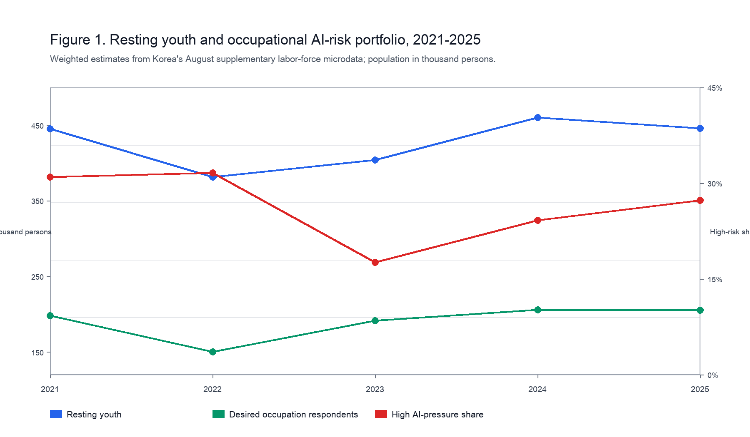
Figure 1. Resting youth and occupational AI-risk portfolio, 2021-2025.

5.2 AI exposure is moderate on average but concentrated in vulnerable entry pathways
The 2025 portfolio's average AI substitution-pressure score is 56.6/100, and the average demand-outlook score is 59.3/100. High AI-pressure occupations account for 27.3% of the desired portfolio, equivalent to 56.0 thousand resting youth. Weak-outlook occupations account for 33.8%, equivalent to 69.2 thousand. The task-exposure-equivalent count is 116.1 thousand.
The high-pressure group is primarily clerical support plus sales. Clerical support is the clearest substitution-risk pathway because its tasks overlap strongly with data entry, document production, record keeping, basic accounting, scheduling, and information routing. Sales work is smaller in the aspiration portfolio, but its entry-level component overlaps with cashiering, simple product information, ticketing, and digitally mediated customer response. Figure 2 shows the two-dimensional nature of the forecast. The lower-right quadrant - high AI pressure and weak outlook - is the most concerning. Clerical support lies clearly in this quadrant. Sales lies near the boundary, reflecting both direct substitution pressure and weak retail outlook.
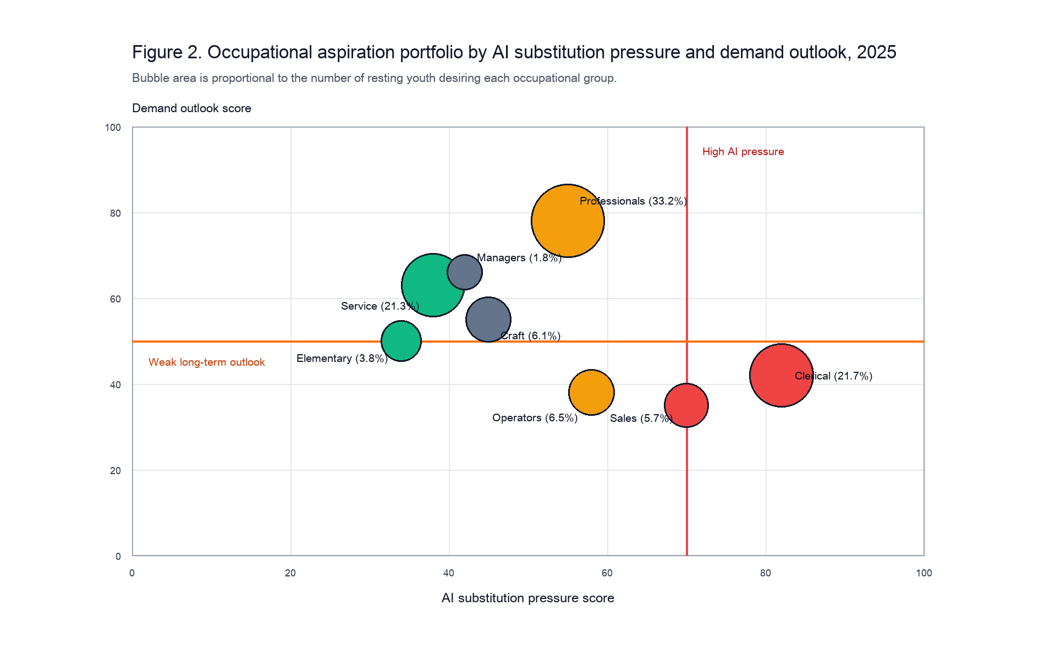
Figure 2. Occupational aspiration portfolio by AI substitution pressure and demand outlook, 2025.
Professionals are different. They are highly important in the portfolio and have substantial AI exposure, but their demand outlook is strong. The forecast implication is not that professional aspirations should be discouraged. Rather, labor-market programs should treat them as AI-augmented pathways requiring stronger bridges into work: portfolio building, domain-specific AI use, data literacy, and supervised work experience.

5.3 Exposure is higher for women and for tertiary-educated resting youth
The portfolio-risk profile differs by sex and education. Women in the occupational-aspiration sample have a higher average AI substitution-pressure score than men (58.4 versus 55.5), partly because women are more concentrated in professional, clerical, and sales aspirations, while men are more represented in operators, craft, and elementary occupations. The high AI-pressure share is 33.1% for women and 23.4% for men.
Education reveals a different pattern. University graduates have the highest broad AI-exposure share because they concentrate in professional and clerical aspirations. Junior-college graduates have the highest high-pressure share and the largest weak-outlook share, reflecting a combination of clerical, sales, and operator aspirations. High-school graduates show a lower average AI-pressure score because they are more concentrated in service, craft, and elementary occupations, but this should not be interpreted as labor-market security. Lower AI substitutability can coexist with lower job quality, lower wages, and weaker career ladders.
Table 3. Segment-level exposure among resting youth with desired occupations, 2025
Segment | Persons | Mean AI | High pressure | Broad exposure | Weak outlook
Men | 123.1 | 55.5 | 23.4 | 63.6 | 33.5
Women | 81.9 | 58.4 | 33.1 | 72.1 | 34.2
University | 89.5 | 60.7 | 33.3 | 82.6 | 34.9
High school | 67.3 | 47.6 | 11.5 | 37.8 | 17.9
Junior college | 46.6 | 62.5 | 39.5 | 81.5 | 55.7
Middle school or less | 1.6 | 38.0 | 0.0 | 0.0 | 0.0

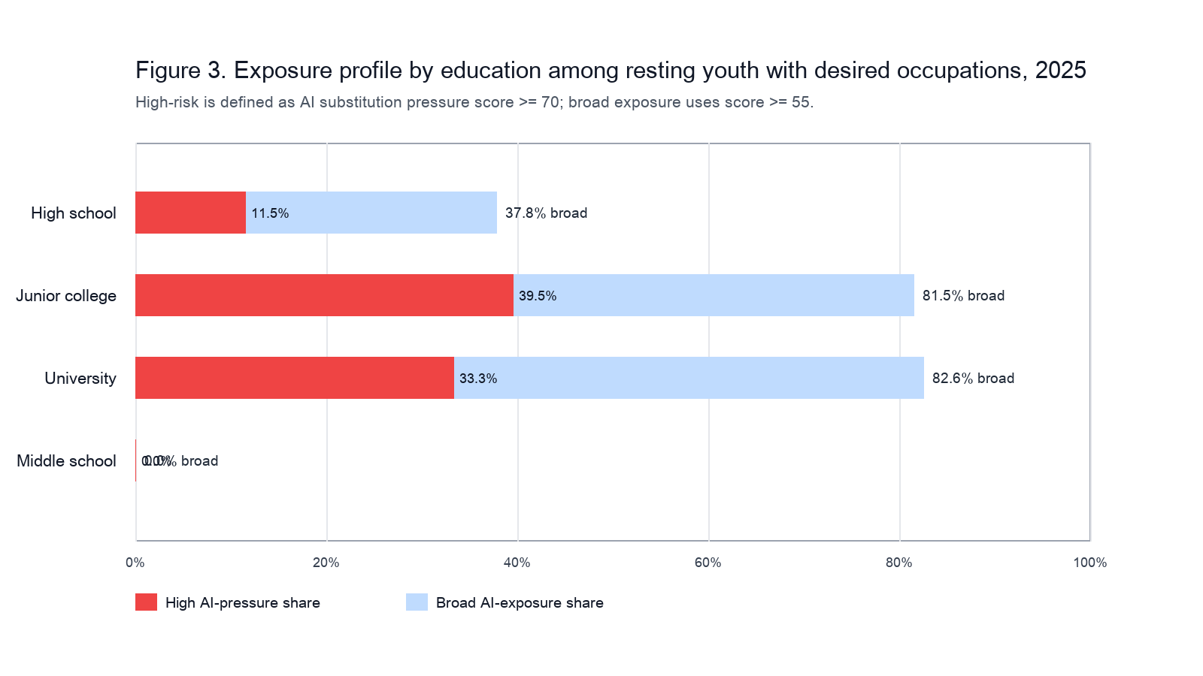
Figure 3. Exposure profile by education among resting youth with desired occupations, 2025.

5.4 Sensitivity checks
The threshold sensitivity shows that the exact high-risk share depends on whether professional and operator groups are treated as exposed. At a cutoff of 70, the high-pressure share is 27.3%. At a broader cutoff of 55, the share rises to 67.0% because professionals and operators enter the exposed set. This distinction is substantively meaningful. The narrow measure captures direct substitution risk; the broad measure captures exposure to AI-mediated task transformation.
Table 4a. Threshold sensitivity
AI-pressure threshold | Exposed | Exposed share
50 | 137.3 | 67.0
55 | 137.3 | 67.0
60 | 56.0 | 27.3
65 | 56.0 | 27.3
70 | 56.0 | 27.3
75 | 44.4 | 21.7
80 | 44.4 | 21.7

Table 4b. Adoption-scenario sensitivity
Scenario | Mean AI pressure | Task-exposure equivalent
Low Adoption | 55.3 | 113.3
Baseline | 56.6 | 116.1
High Adoption | 58.0 | 118.8

The adoption-scenario sensitivity is less volatile because occupation shares dominate score changes at the one-digit level. Under the low-adoption scenario, the task-exposure-equivalent count is 113.3 thousand; under the high-adoption scenario it is 118.8 thousand. The main qualitative conclusion is unchanged: a nontrivial minority of resting youth target directly substitutable occupations, while a larger share target occupations that are transformable rather than simply declining.

6. Discussion
The results point to an aspiration-exposure mismatch that is not visible in standard employment statistics. Resting youth are outside employment and active job search, so occupational exposure cannot be measured from current jobs. However, many still report desired occupations. Those desired occupations reveal where future re-entry may become more difficult as AI diffuses.
The first implication is that AI risk for resting youth is segmented. Clerical and sales aspirations need direct transition support because these pathways are exposed to automation and weak demand. For these groups, generic job-search counseling is insufficient. Training should reframe clerical work as AI-enabled administrative operations, with emphasis on workflow design, verification of AI outputs, privacy, cybersecurity, exception handling, and client communication. Sales pathways should move from cashiering and simple product information toward customer relationship management, consultative sales, live commerce operations, and data-supported merchandising.
The second implication is that professional aspirations require capability upgrading rather than redirection away from professional work. Professionals are the largest desired group and have the strongest outlook. But entry-level professional tasks - drafting, coding, summarizing, design iteration, data cleaning, and analysis support - are precisely the tasks most likely to be changed by generative AI. This creates an entry paradox: the occupations remain attractive, but the tasks that previously trained novices may be automated or accelerated. Career programs for resting youth therefore need to provide substitute learning environments: supervised projects, work-integrated learning, occupational portfolios, and AI-tool fluency tied to domain-specific standards.
The third implication is that lower AI exposure is not the same as better opportunity. Service and elementary occupations may be less directly exposed to LLMs, but they can be characterized by low wages, irregular hours, physical demands, and limited progression. Forecasting should therefore integrate technological exposure with job quality and mobility, not treat non-automation as a success condition.
For TFSC's broader agenda, the paper shows how technology forecasting can be connected to inactive populations. Foresight exercises usually estimate how future technology will affect existing industries, occupations, or firms. This study shifts attention to a pre-employment margin: how future work structures shape the occupational aspirations of those not currently matched to jobs. This is especially important in aging societies where youth labor-market detachment has long-run consequences for human-capital accumulation, fertility, fiscal capacity, and social cohesion.

7. Policy implications
Policy should move from one-size-fits-all activation to portfolio-specific transition design.
First, public employment services should triage resting youth by desired occupation and exposure type. The relevant categories are not simply "job-ready" and "not job-ready"; they include high-substitution aspirations, AI-augmented growth aspirations, relational service pathways, and low-quality low-exposure pathways.
Second, AI literacy programs should be occupationally embedded. A generic prompt-engineering course is unlikely to help clerical, sales, service, and professional aspirants equally. Clerical programs should focus on administrative workflow and document verification. Professional programs should focus on domain-specific AI use and portfolio evidence. Service programs should focus on human-AI coordination in customer service, care, hospitality, and logistics.
Third, employers need incentives to preserve and redesign entry-level learning tasks. If firms automate junior tasks without creating new apprenticeship structures, resting youth and new graduates may lose the work-based learning routes that historically enabled occupational entry. Public procurement, wage subsidies, and training grants can condition support on structured entry-level supervision rather than only headcount.
Fourth, policy evaluation should track occupational aspirations as a leading indicator. Standard labor-force outcomes observe re-entry after it happens. Desired-occupation portfolios can reveal future pressure points earlier, especially when linked to technology outlooks.

8. Limitations and future research
The analysis has four limitations. First, the occupation variable is available only at the major-group level. This masks large within-group heterogeneity. For example, "professionals" includes occupations with very different AI exposure and demand prospects. Future work should use more detailed desired-occupation fields or link survey data to administrative employment histories.
Second, the index is a transparent foresight index, not an observed causal estimate. It triangulates ILO, WEF, KEIS, KLI, OECD, and task-exposure research, but the scoring still involves judgement. Future work could improve the index by using a formal Delphi panel, Korean task descriptions, and multiple independent raters.
Third, the microdata are repeated cross-sections. The analysis cannot determine whether a specific individual remains resting, changes desired occupation, or enters work. Panel data would allow transition modeling and causal analysis of whether AI-exposed aspirations predict delayed re-entry.
Fourth, the analysis does not model wages, job quality, regional labor demand, or firm adoption. These dimensions are essential for policy design. A low-AI-exposure job may still be undesirable or unstable; a high-exposure job may become more productive and better paid for workers who can use AI.

9. Conclusion
Generative AI changes the labor-market problem faced by inactive youth. It does not only threaten existing jobs; it alters the attractiveness, accessibility, and skill requirements of the jobs that young people hope to enter. In Korea, 2025 labor-force microdata show that approximately 205.0 thousand resting youth report desired occupations, with one third targeting professional work and another large share targeting clerical and service work. Linking these aspirations to a two-dimensional foresight index shows that 27.3% of desired occupations are in high AI-pressure groups and 33.8% are in weak-outlook groups. The results call for occupationally differentiated activation policy: protect and redesign entry routes in AI-substitutable clerical and sales work, build AI-complementary capabilities for professional pathways, and treat low-exposure service work as a job-quality challenge rather than a technological safe harbor.

Declaration of generative AI and AI-assisted technologies in the manuscript preparation process
During the preparation of this draft, the author used OpenAI Codex/ChatGPT to assist with data processing, figure generation, literature organization, and language drafting. The author must review and edit the content as needed and takes full responsibility for the content of the submitted manuscript.

Data availability statement
The analysis uses Statistics Korea microdata files supplied by the user for the 2021-2025 August supplementary labor-force survey. The derived aggregation scripts, index assumptions, tables, and figures are stored with this draft. Public redistribution of the raw microdata should follow the conditions of the source data provider.

References
Acemoglu, D., & Restrepo, P. (2020). Robots and jobs: Evidence from US labor markets. Journal of Political Economy, 128(6), 2188-2244.
Arntz, M., Gregory, T., & Zierahn, U. (2016). The risk of automation for jobs in OECD countries: A comparative analysis. OECD Social, Employment and Migration Working Papers, No. 189.
Autor, D. H., Levy, F., & Murnane, R. J. (2003). The skill content of recent technological change: An empirical exploration. Quarterly Journal of Economics, 118(4), 1279-1333.
Bank of Korea. (2026). Characteristics and assessment of resting youth: Comparative analysis by nonemployment type. BOK Issue Note No. 2026-3. https://www.bok.or.kr/portal/bbs/P0002353/view.do?depth=200433&menuNo=200433&nttId=10095939&programType=newsData&relate=Y
Atkinson, T., & Yamco, S. (2026). Young workers' employment drops in occupations with high AI exposure. Federal Reserve Bank of Dallas. https://www.dallasfed.org/research/economics/2026/0106
Brynjolfsson, E., Chandar, B., & Chen, R. (2025). Canaries in the coal mine? Six facts about the recent employment effects of artificial intelligence. Stanford Digital Economy Lab. https://digitaleconomy.stanford.edu/publication/canaries-in-the-coal-mine-six-facts-about-the-recent-employment-effects-of-artificial-intelligence/
Brynjolfsson, E., Mitchell, T., & Rock, D. (2018). What can machines learn, and what does it mean for occupations and the economy? AEA Papers and Proceedings, 108, 43-47.
Eloundou, T., Manning, S., Mishkin, P., & Rock, D. (2023). GPTs are GPTs: An early look at the labor market impact potential of large language models. arXiv:2303.10130. https://arxiv.org/abs/2303.10130
Felten, E., Raj, M., & Seamans, R. (2021). Occupational, industry, and geographic exposure to artificial intelligence: A novel dataset and its potential uses. Strategic Management Journal, 42(12), 2195-2217.
Frey, C. B., & Osborne, M. A. (2017). The future of employment: How susceptible are jobs to computerisation? Technological Forecasting and Social Change, 114, 254-280.
Gmyrek, P., Berg, J., Bescond, D., & others. (2025). Generative AI and jobs: A refined global index of occupational exposure. International Labour Organization. https://www.ilo.org/publications/generative-ai-and-jobs-refined-global-index-occupational-exposure
Jang, J., Jeon, B., Jeong, J., Lee, C., Shim, J., & Ahn, S. (2024). Employment effects of artificial intelligence development. Korea Labor Institute Research Report 2024-08. https://dl.kli.re.kr/library/10320/contents/7150962
Korea Employment Information Service. (2024). Medium- to long-term labor supply and demand outlook, 2023-2033. https://www.keis.or.kr/keis/ko/proj/113/pblc/detail.do?categoryIdx=131&pubIdx=11209
OECD. (2023). OECD Employment Outlook 2023: Artificial intelligence and jobs. OECD Publishing. https://www.oecd.org/en/publications/2023/07/oecd-employment-outlook-2023_904bcef3/full-report/artificial-intelligence-and-jobs-no-signs-of-slowing-labour-demand-yet_5aebe670.html
OECD. (2026). Youth not in employment, education or training (NEET). OECD Data. https://www.oecd.org/en/data/indicators/youth-not-in-employment-education-or-training-neet.html
Webb, M. (2020). The impact of artificial intelligence on the labor market. Stanford University working paper.
World Economic Forum. (2025). The Future of Jobs Report 2025. https://www.weforum.org/publications/the-future-of-jobs-report-2025/

